Appendix B
(Clause C5 of additional conditions of contract)

Guidelines on Scope and Contents of Subcontractor Management Plan

The Subcontractor Management Plan shall include (but not limited to) the following:

  - Scope of works to be subcontracted including the form and extent of subcontracting arrangement such as labour only, labour and plant, labour and material, plant only, lump sum or any other combination of types. Proof of ownership of construction plant and material shall be addressed. The scope of works to be subcontracted shall comply with the relevant contractual provisions (i.e. the ACC for Limiting the Tiers of Subcontracting).

  - Particulars of subcontracts (irrespective of tiers) as required under the Template under Table 1.

  - The Contractor’s approach to demand/ensure his subcontractor(s) to a) abstain from subcontracting the whole of the works subcontracted to him/them, and b) report upwards his/their subcontracting arrangement and any subsequent changes with written declarations of no “hidden” subcontracts for any part of the works subcontracted to any of them.

  - The Contractor’s proposed measures for supervision of the works and monitoring of the performance of subcontractors, particularly the aspects of the works programming, quality and safety of the works and environmental protection.

  - The Contractor’s proposed measures for monitoring the performance of the subcontractors in complying with the requirements in the contract in reporting site accidents.

  - The Contractor’s approach to ensure all subcontractors, irrespective of tiers, to incorporate the Mandatory Subcontract Conditions for Prohibition of Imposing Administrative Charges for Reporting of Site Accidents and Elimination of Under-reporting of Site Accidents.

  - Criteria for selection of subcontractor(s) involving trade(s) not available in the Registered Specialist Trade Contractors Scheme (RSTCS).

  - The Contractor’s approach to ensure all his subcontractor(s) (irrespective of tiers) to adopt written contracts in his/their subcontracting and that all the subcontract(s) comply with the requirements as stipulated in the Contract (i.e. ACC for Subcontract conditions) and incorporate the Mandatory Subcontract Conditions for Security of Payment and SOP Provisions for Relevant Subcontracts in the form appearing in Appendix O of the additional conditions of contract.

  - Details of the Contractor’s Management Team, as required in the Contract (i.e. the ACC for Contractor’s Management Team), employed on direct supervision and management of subcontractor(s). An organization chart showing the responsibilities of the Contractor’s direct staff in supervision and management of his subcontractor(s) shall be submitted.

  - Declaration through the standard declaration form that members of staff on the Contractor’s Management Team are prohibited to be given a subcontract to any part of the works or to have a vested interest in any of the subcontractors irrespective of tiers.

  - The Contractor’s proposed measures to ensure the compliance with the implementation of the system of payment of wages to the Site Workers as stipulated in the Contract (i.e. ACC for Payment of Wages of Site Workers). The Contractor’s proposed measures for ensuring timely payments to subcontractor(s) and payments by subcontractor(s) to subcontractor(s) of lower tiers.

[NB. The above items are not exhaustive. The Contractor can add any other items, which he considers pertinent to the proper management of his subcontractor(s).]

Standard Declaration Form by the Contractor

on Compliance with Provisions in

Subcontractor Management Plan

To: The Project Manager
Contract No. | :
Contract Title | :

In accordance with the Guidelines on Scope and Contents of Subcontractor Management Plan referred in ACC C5, I / we declare and confirm that we have complied with and undertake to continue to comply with the following provisions, and declare and confirm that I / we have ensured and undertake to continue to ensure that our members of staff on the Contractor’s Management Team as referred in ACC D1 are aware of the following provisions:

- Members of staff on the Contractor’s Management Team are prohibited from being given a subcontract to any part of the works or having a vested interest in any of the subcontractors irrespective of tiers;

- Members of staff on the Contractor’s Management Team are required to submit written declarations to the Project Manager upon his / her written request from time to time or at any time that they do not have a subcontract to any part of the works or any vested interest in any of the subcontractors irrespective of tiers.

(Name of the Contractor)
(Name of the Signatory)
(Position of the Signatory)
(Date)

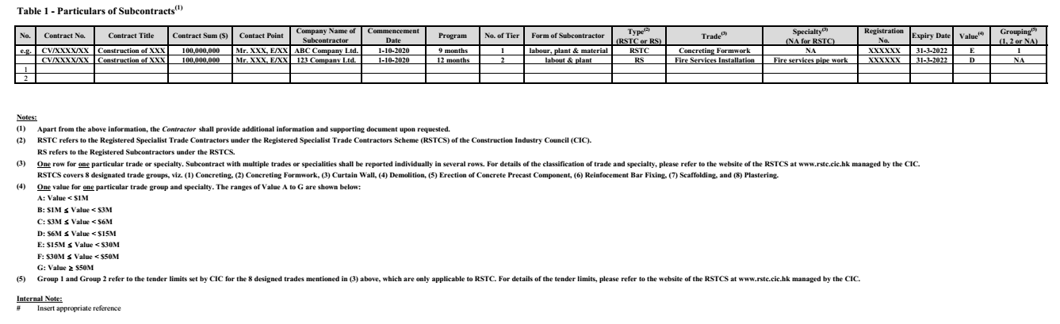

[BLANK PAGE]

